

**Get 2 know U BINGO - Get 2 know U BINGO - Get 2 know U BINGO**

A Champion Chum

‘Full House’

A Perfect Pal

‘Full Row’

The Best BFF

‘Full column’

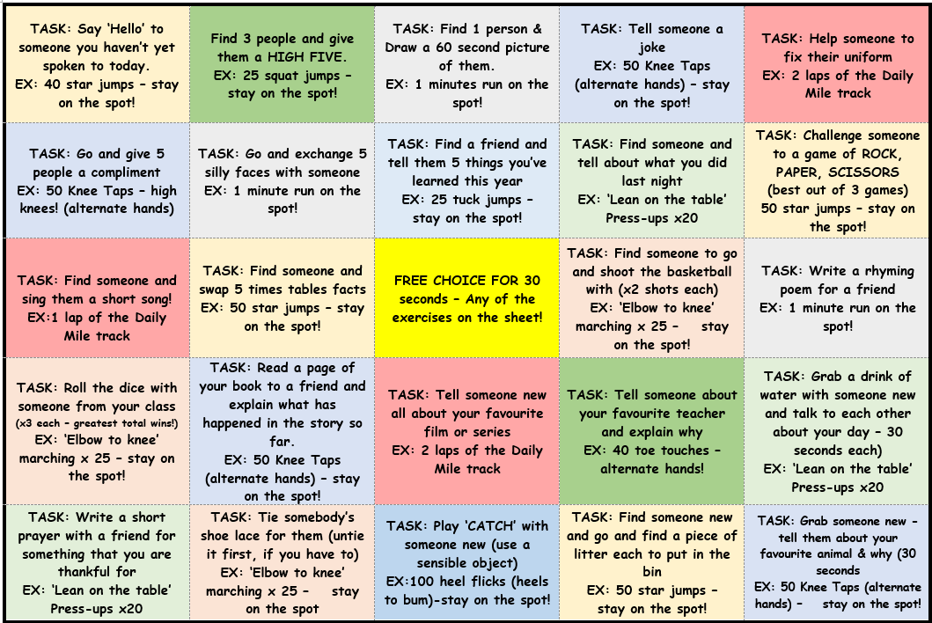

I am The Best BFF

(Column)

I am The Perfect Pal (Row)

I am A Champion Chum

(Full House)